Barcode Printing for Library
Go To CMS >>> Library >>> Stock Management >>> Print Barcode
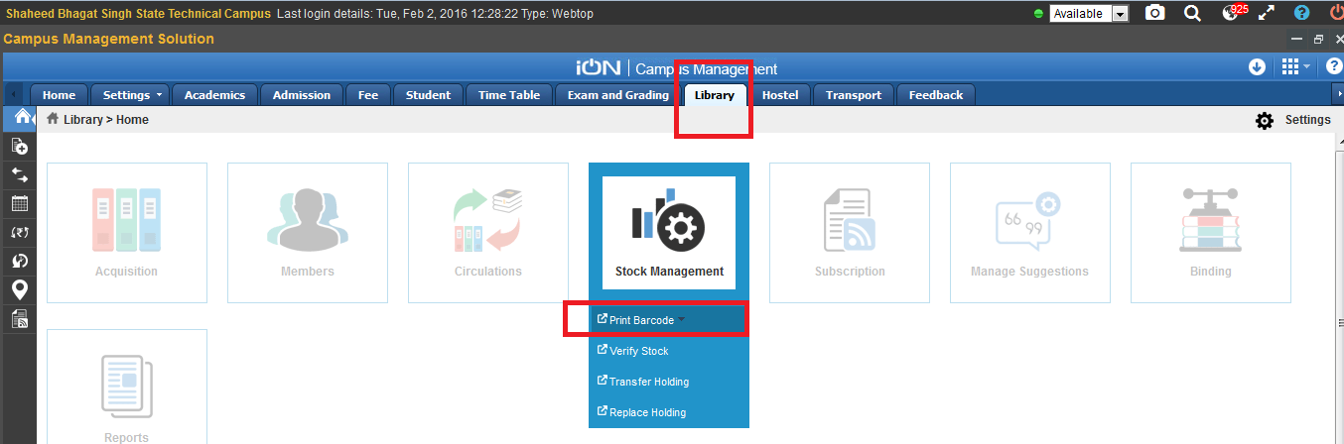
Select the Library from binoculars as shown below and click on search. It will show the list of all the Library Holdings.
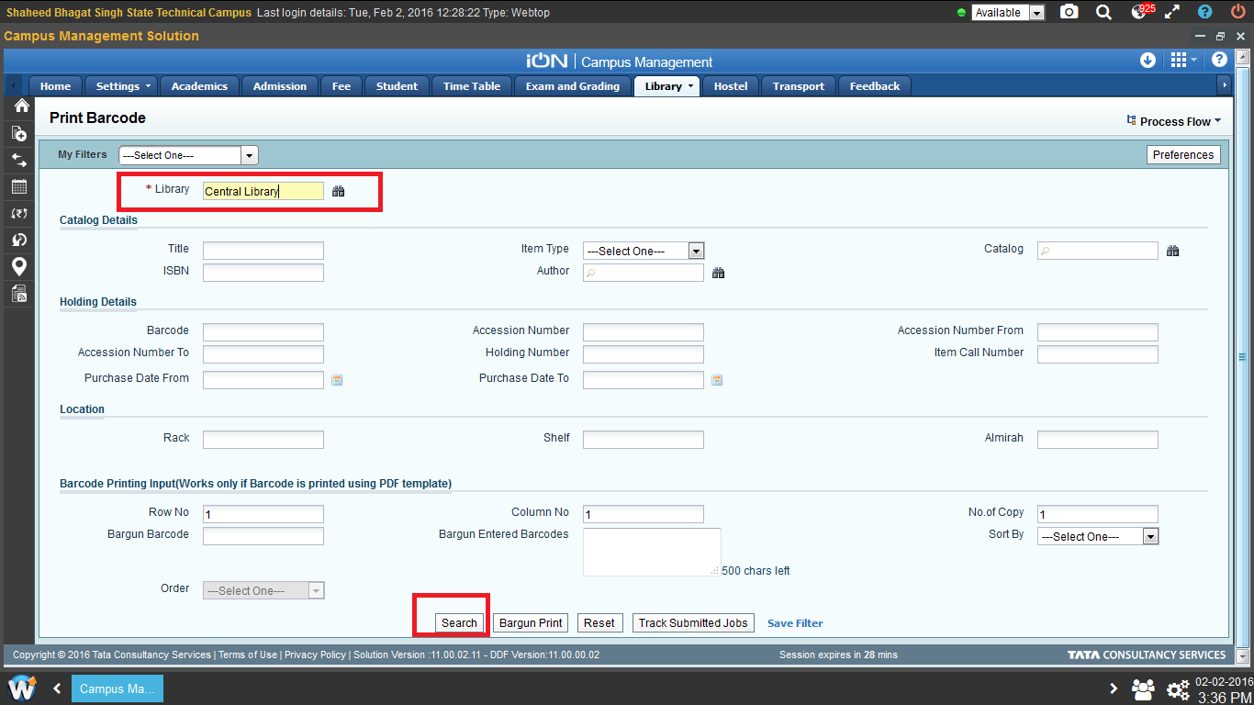
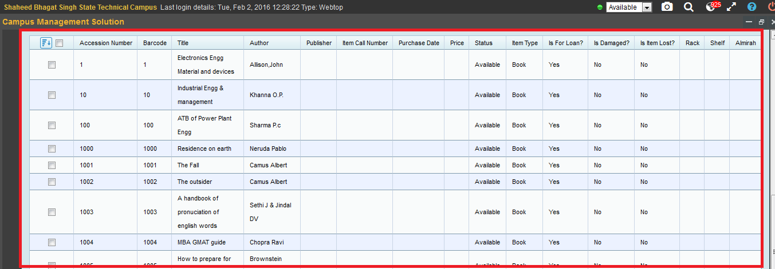

Select the holdings for which you need to print barcodes and click on Print or click on Print All if you need to print barcodes for all holdings as shown below.

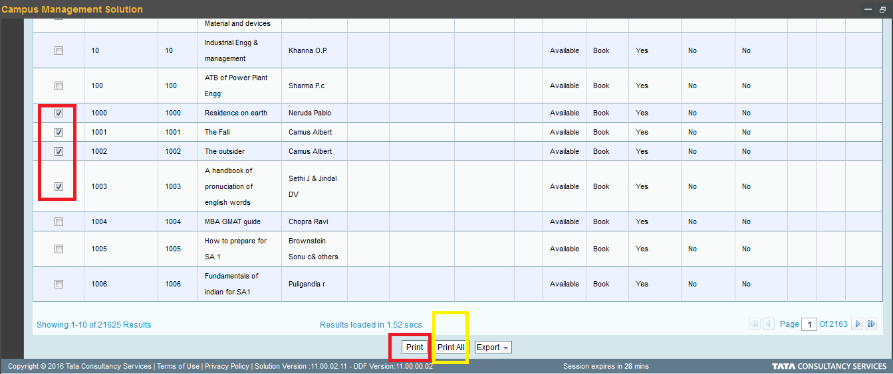
After clicking on Print a request is raised for printing barcodes as shown below.
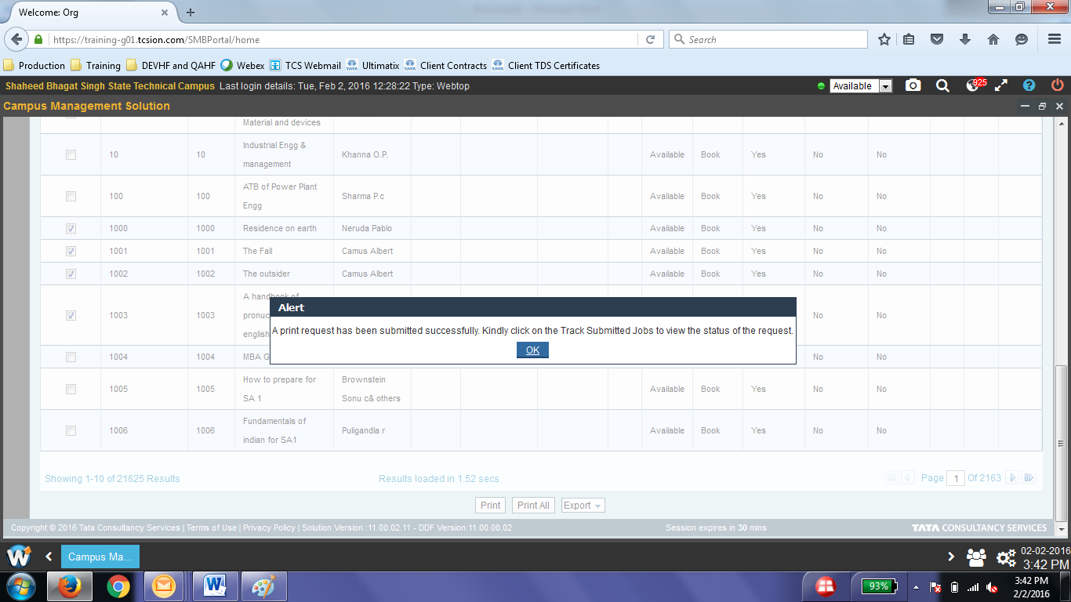
To take print of the requested barcodes , click on Track Submitted Jobs as shown below
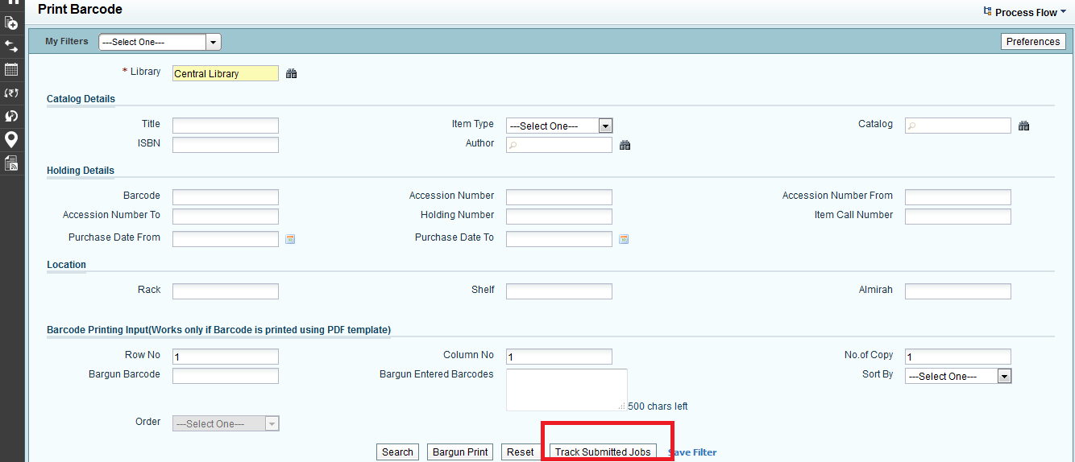
After clicking on Track Submitted Jobs , a window will open for requested print jobs. Click on the link for of generated and take print of the same for pasting on Books as per their accession number.

